

**CSE260**

Digital Logic Design

Group-1: Lab Project Report

**Project Name: 32 Second Traffic Light Controller.**

**Students Information:**

|  |  |  |
| --- | --- | --- |
| **Name** | **ID** | **Theory Section** |
| Ananna Paul | 20201038 | 3 |
| Sanjida Tamanna | 20201117 | 3 |
| Sabuz Ahmed | 20201050 | 3 |
| Saiara Kabir | 21301200 | 3 |

**Introduction:**

**In this global arena, we are passing through a crowd of vehicles. Traffic signal legislation should be strictly maintained for a safe journey. In this process through modern technologies we can add a new dimension by implementing a digital traffic light controller. In our group project, we have tried our best to design a 32-second traffic light controller. We have used a counter circuit, Light controller, and emergency traffic controller. Through these we will be able to control 4 lane's traffic signal. We have used Green, yellow, and red for direction. With help of the counter circuit we will count 0 to the 31-second timetable, through light controller we will render the signal. Such as from the count of 0 to 6 second traffic light gives green signal,6 to 8 yellow and 8 to 30 yellow for one lane and the next lane will be appeased by 8 seconds and goes on. We have included an Emergency traffic light controller which works through relays and magnitude comparators. It works for emergency moments for instance when the ambulance or an honourable person of a nation moves. In this project, we think we have satisfied perfect and safe traffic signal fundamentals.**

**Proposed Model:**

We will create a 32 second 4-way traffic light controller using Flip-Flops, Parallel Adders and Magnitude Comparators. It will also have a button to pause the signals and emergency input to give Green-Light to any specific road for emergency situations.

**Experimental Setup:**

Components used:

1. Proteus Design Suite software.
2. IC 4008- 4 Bit Parallel Adder
3. IC 7485 - 4 Bit Magnitude Comparator
4. D-Flip-Flop
5. LED- Red, Green, Yellow
6. Button and Relay
7. AND, NOR, NOT Gates
8. Digital Clock Power Source, LogicState for input

**Diagram:**

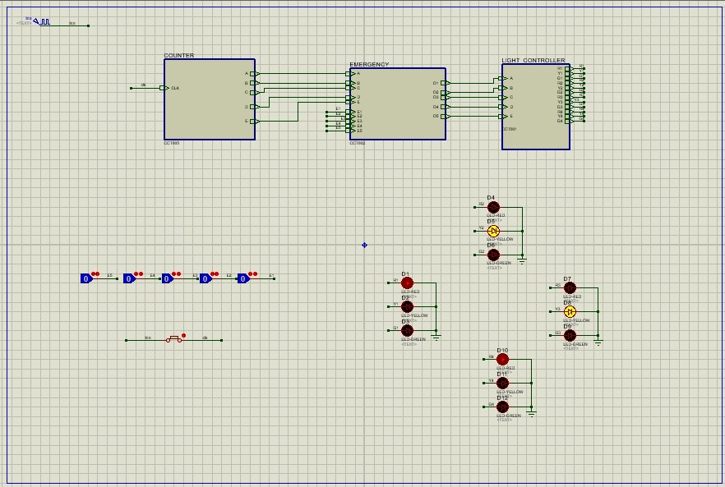

Fig: 32 second Traffic Light Controller

**Results and Analysis:**

**Counter:**

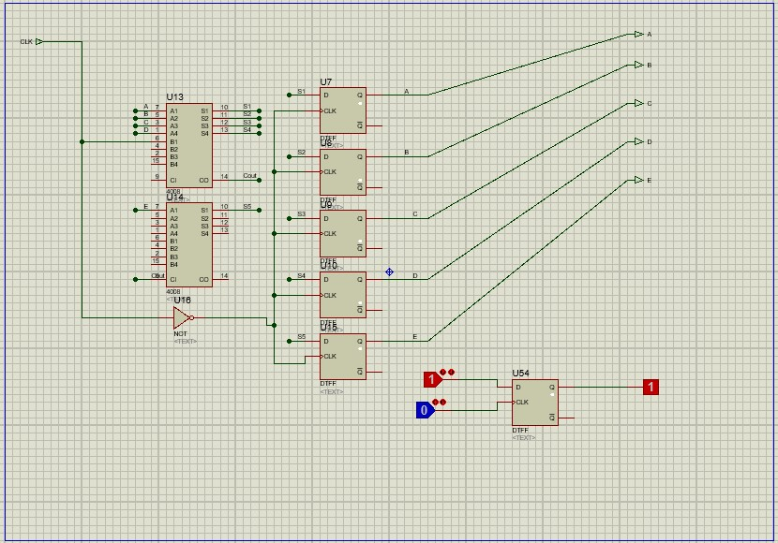

**Counter circuit is the main circuit of our project. Here we have taken only one input Clock consisting of 1 Hz.That stands 1/2 second for 0 and 1/2 second for 1 . We have used 4 bit parallel adder works as 5 bit parallel adder. The local input variables are A,B,C,D,E and outputs are s1,s2,s3,s4,s5. Also we have taken 5 D-Flip -Flop boxes which stores 0 by default(D) and takes input in clk and restores that value again.We have those time inputs in local variables which derive from flip flop.That implies at first we have input time local variables as 0 . A Not-gate has been attached with clock and with D-Flip-Flop box. When the Input Clock gives 1 Not gate turns it into 0 and D-Flip-Flop stores that value and passes it into parallel adder and parallel adder adds**

**1 with that value and gives output 1. Again when the input clock gives 0 it turns into 1 D Flip Flop box previous restored value is 1 and the value goes to parallel adder and turns into 2 then the output comes for B .This process continues for 31 bit and when 32 bit arrives the process gets 0. By this process the counter circuit controls the time process .**

**Traffic Light Controller:**

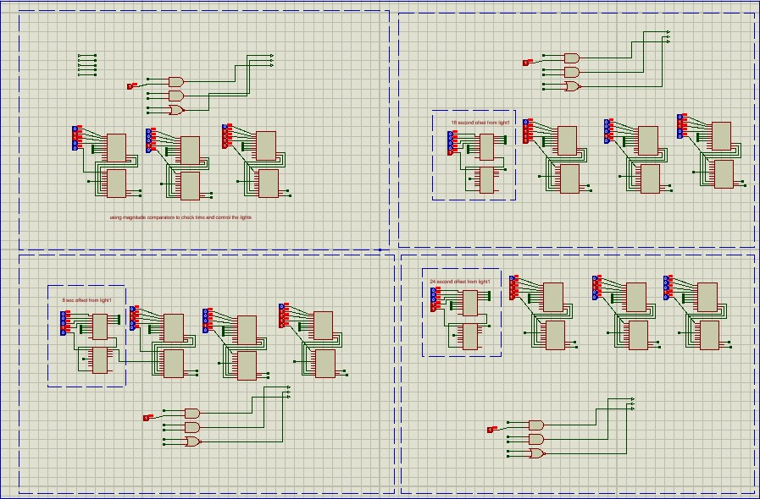

This sub circuit takes 5 Time Variables(A,B,C,D,E) as inputs and outputs the logic states of 12 Traffic LEDs of 4 different traffic light sets. For Traffic light set-1, we used magnitude comparators to check the time. Then we applied the equation : 0 < Green < 6 < Yellow < 8 < Red < 30 <Yellow. Then for the traffic light set - 2 , 3 , 4; we offsetted respectfully +8, +16, +24 seconds using parallel adders and applied the same equation for all of them. This gives us 4 different states of all traffic light sets in each second. Each traffic light set gets 8 seconds of “Go” time and 24 seconds of “Stop” time.

**Emergency:**

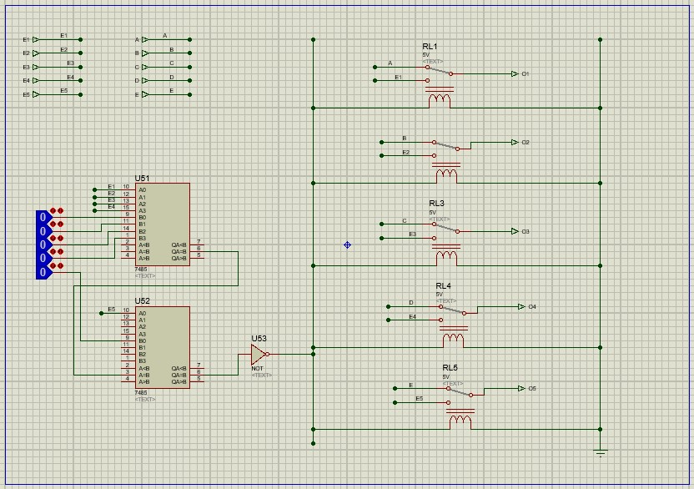

In our project, there are a total of 10 inputs and 5 outputs under the Emergency Sub Circuit. Among those 10 inputs, the first 5 inputs are A, B, C, D, and E which is time and another 5 inputs are Emergency 1 to Emergency 5. To begin with, using Magnitude Comparator first we have to compare all the inputs of emergency and justify whether all the inputs are zero or one.

If all the inputs of emergency are 0 then our Emergency circuit will return A, B, C, D and E (Time) as an output.

On the other hand, among all the inputs of emergency, if one input is equal to value 1 or at least one value is 1 then our circuit will return the Emergency variable as an output instead of returning the time variable as an output.

In addition, here we have used a relay instead of XOR gate because if we have used XOR gate so, the circuit will turn into more complicated.

**Conclusion:**

Our Traffic Light Controller functions reasonably well. It can be used in streets where budget and maintenance capabilities are low. It takes nearly zero experience to operate. We think we can reduce the traffic jams in smaller roads by using our Traffic Controller.